A RARE CASE OF URINARY BLADDER LEIOMYOMA AND ITS MANAGEMENT

ANEES PUTHAWALA1, MOHAMMED FAROOQ1, GRIFFIN M1*, MUTHULATHA N1

1 DEPARTMENT OF UROLOGY, SAVEETHA MEDICAL COLLEGE AND HOSPITAL, SAVEETHA INSTITUTE OF MEDICAL AND TECHNICAL SCIENCES (SIMATS), SAVEETHA UNIVERSITY, CHENNAI, IND

* CORRESPONDING AUTHOR:

DR. GRIFFIN M

# Abstract

Bladder leiomyoma is a rare, benign tumor of the urinary bladder. Though uncommon, it is the most prevalent type of benign mesenchymal tumor found in the bladder. Diagnosis often involves a combination of imaging techniques, with definitive confirmation through histopathology. Treatment is primarily surgical, with the approach depending on the tumor's size and location. We present the case of a 40-year-old female with a bladder leiomyoma who was successfully treated with open transvesical enucleation after initial Transurethral resection.

# INTRODUCTION

The majority of bladder tumors originate from the urothelium and are typically malignant. Benign mesenchymal tumors of the bladder are infrequent, accounting for only 1-5% of all bladder neoplasms. Among these, leiomyoma is the most common, though it still represents less than 0.5% of all bladder tumors. Patients may present with a variety of symptoms, including obstructive symptoms (49%), irritative symptoms (38%), or hematuria (11%). Diagnostic tools such as cystoscopy, ultrasound, computed tomography (CT), or magnetic resonance imaging (MRI) are utilized, but a definitive diagnosis is established through histopathological examination. The treatment strategy is largely determined by the tumor's size and anatomical position. While small, endovesical leiomyomas can be removed via transurethral resection of the bladder tumor (TURBT), larger intramural or extravesical tumors are more effectively managed with open resection.

# Case Presentation

A 40-year-old female presented with recurrent episodes of painless hematuria accompanied by the passage of clots for 1 year duration on and off with failed conservative treatment and having had multiple blood transfusions.

## Clinical Findings:

* **Abdominal Examination:** Soft and non-tender.
* **Vaginal Examination:** A smooth, firm lesion was palpable on the anterior vaginal wall.
* **Urinalysis:** Showed a significant number of red blood cells per high power field.
* **Urine Culture:** Indicated mixed growth.
* **Urine Cytology:** Negative for malignant cells.

# Imaging and Procedures:

Diagnostic imaging was pursued to further characterize the lesion.

* **USG KUB:** **BLADDER:** A fairly defined heteroechoic lesion of size ~5.3x5.1x5.6cm , volume~80cc with intravesical internal vascularity arising from the wall of bladder likely posterior wall

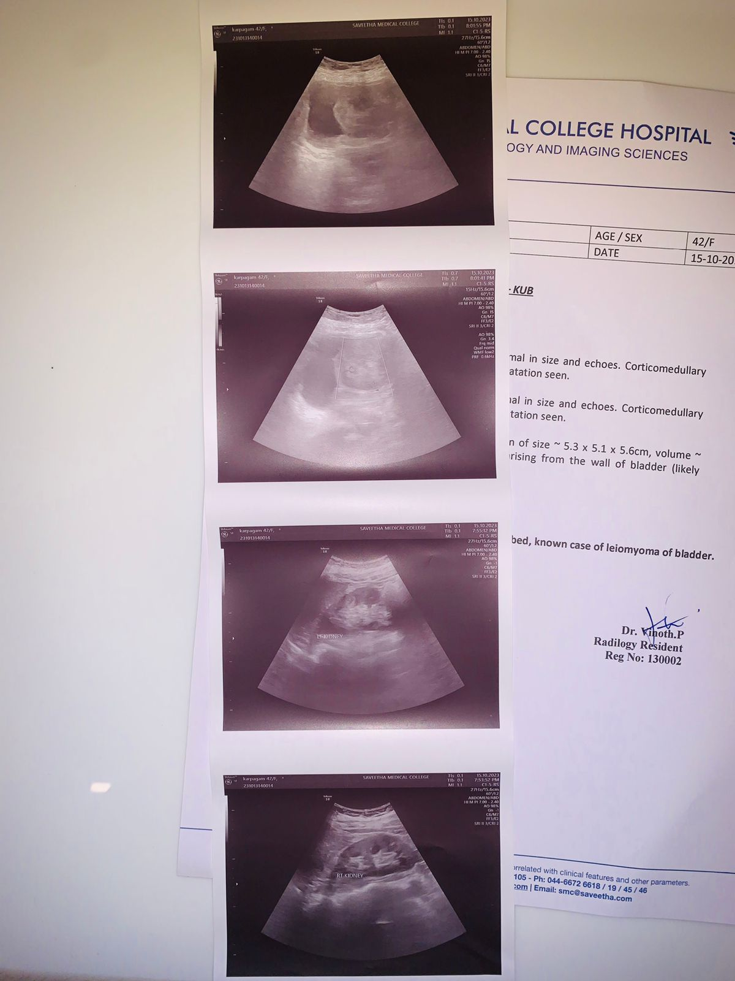 

* **CECT Urogram**

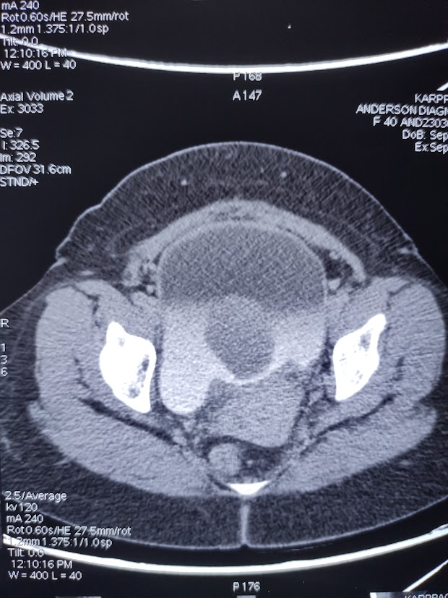 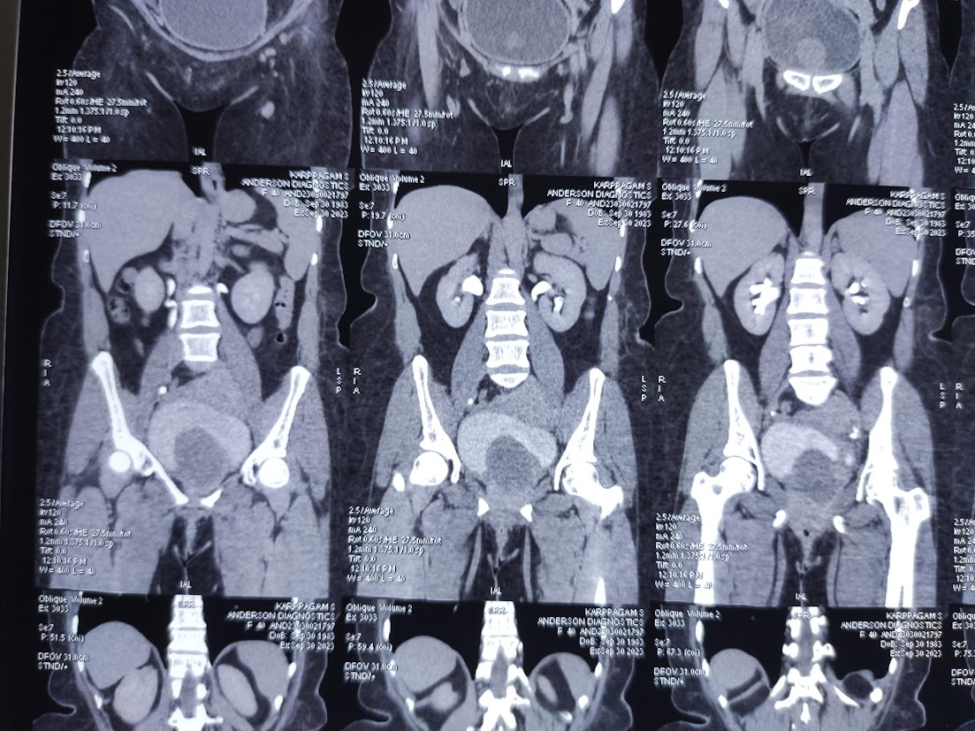

**BLADDER :**HOMOGENOUSLY ENHANCING SOFT TISSUE DENSITY MASS LESION MEASURING ~70 X 55 X 54 MM NOTED IN BASE OF BLADDER EXTENDING INTO PROXIMAL URETHRA AND INDENTING THE CERVIX.

**IMPRESSION**

HOMOGENOUSLY ENHANCING SOFT TISSUE DENSITY MASS LESION NOTED IN BASE OF BLADDER EXTENDING INTO PROXIMAL URETHRA AND INDENTING THE CERVIX.

NO SIGNIFICANT RETROPERITONEAL/PELVIC LYMPHADENOPATHY

LIKELY LEIOMYOMA BLADDER

* **PET-CT with MR-Fusion:**

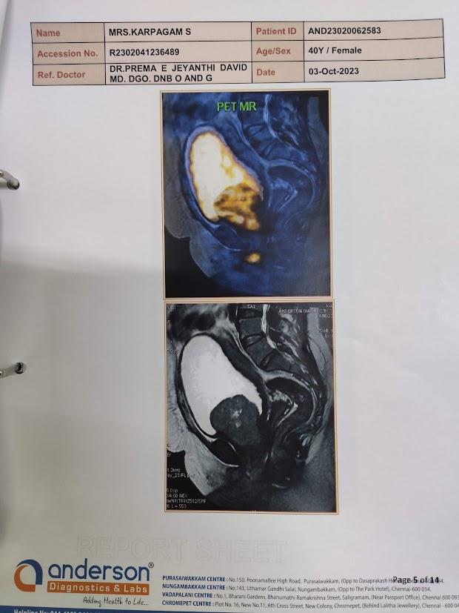 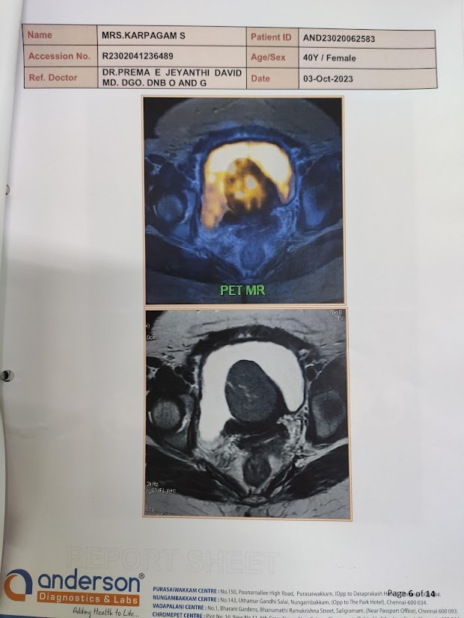

**IMPRESSION:**LARGE LOBULATED METABOLICALLY ACTIVE HETEROGENOUSLY ENHANCING T2 INTERMEDIATE SIGNAL INTRALUMINAL SOFT TISSUE MASS MEASURING ~6.8 X 5.7 X 4.7 CM NOTED ARISING FROM THE BASE OF URINARY BLADDER/BLADDER NECK WITH EXTENSION INTO THE UPPER URETHRA**(SUV MAX=5)**

* POSTERIORLY THE LESION INDENTS THE VAGINA WITH NO OBVIOUS INVASION
* LESION SHOWS MILD HETEROGENOUS DIFFUSION RESTRICTION
* NO INVOLVEMENT OF VESICOURETERIC JUNCTION
* URINARY BLADDER APPEARS DIFFUSELY THICK WALLED WITH TRABECULATIONS SUGGESTIVE OF UNDERLYING CYSTITIS.
* BROAD BASED DIVERTICULUM IS NOTED IN THE RIGHT POSTEROLATERAL WALL OF URINARY BLADDER JUST LATERAL TO THE VUJ
* Vaginoscopy: Confirmed the presence of the lesion.

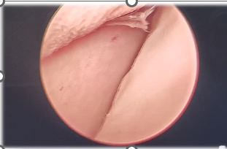

* **TURBT (Transurethral Resection of Bladder Tumor):** A biopsy was taken via TURBT for histopathological analysis.

## 

## Surgical Intervention and Histopathology:

Based on the findings, the patient underwent a definitive surgical procedure.

* Procedure: Open transvesical leiomyoma enucleation was performed. This involved an anterior vesicotomy to access and enucleate the tumor.

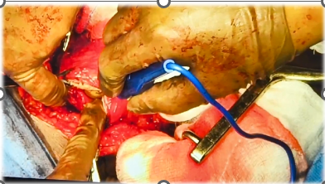 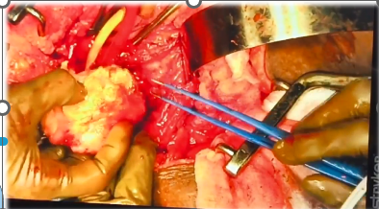

* Histopathology (HPE): The excised tissue showed focal transitional epithelium with areas of extensive squamous metaplasia. The underlying lesion was composed of spindle-shaped cells arranged in sheets and fascicles. There were areas of necrosis with surrounding inflammatory infiltrate and very occasional mitotic figures. Immunohistochemistry revealed diffuse SMA positivity and a mildly elevated Ki67 index (5%). These features were consistent with a smooth muscle neoplasm, confirming the diagnosis of leiomyoma.

# DISCUSSION

This case highlights the typical presentation and management of a large bladder leiomyoma. While imaging modalities like CT and MRI are crucial for initial diagnosis and surgical planning, the definitive diagnosis of bladder leiomyoma rests on histopathological examination. In this instance, the combination of spindle cell morphology, SMA positivity, and a low Ki67 index confirmed the benign nature of the tumor.

The choice of surgical approach is guided by the tumor's characteristics. For smaller, endovesically located tumors, TURBT can be both diagnostic and therapeutic. However, for large, intramural, or extravesical leiomyomas, as seen in this patient, open resection is the preferred method to ensure complete removal. The well-encapsulated nature of most leiomyomas makes them amenable to complete enucleation, which is an effective treatment for these larger tumors.

# CONCLUSION

Bladder leiomyoma is a rare and benign condition. Surgical excision is the cornerstone of management, providing both diagnostic confirmation and definitive treatment. As demonstrated in this case, complete enucleation via an open surgical approach is an excellent treatment option for large leiomyomas. Further research with larger patient cohorts and extended follow-up is necessary to continue evaluating and refining treatment techniques for this uncommon bladder pathology.

**REFERENCES**

1. Campbell E.W., Gislason G.J. Benign mesothelial tumors of the urinary bladder: review of literature and a report of a case of leiomyoma. J. Urol. 1953;70:733–742. doi: 10.1016/S0022-5347(17)67977-1.
2. Melicow M.M. Tumors of the urinary bladder. J. Urol. 1937;37:117. doi: 10.1016/S0022-5347(17)67309-9.
3. Knoll L.D., Segura J.W., Scheilhauer B.W. Leiomyoma of the bladder. J. Urol. 1986;136:906–913. doi: 10.1016/s0022-5347(17)45124-x.
4. Saunders S.E., Conjeski J.M., Zaslau S., Williams J. Leiomyoma of the urinary bladder presenting as urinary retention in the female. Can. J. Urol. 2009;16:4762–4764.
5. Kutzmann A.A. Leiomyoma of urinary bladder. J. Urol. 1937;37:117–132.
6. Wenz W., Sommerkamp H., Dinkel E. Leiomyoma of the bladder. Urol. Radiol. 1986;8:114–117. doi: 10.1007/BF02924092.
7. Fernandez A., Dehesa T.M. Leiomyoma of the urinary bladder floor: diagnosis by transvaginal ultrasound. Urol. Int. 1992;48:99. doi: 10.1159/000282305.
8. McLucas B., Stein J.J. Bladder leiomyoma. a rare cause of pelvic pain. Am. J. Obstet. Gynecol. 1985;153:896. doi: 10.1016/0002-9378(85)90701-x.